20MCA136 – NETWORKING & SYSTEM ADMINISTRATION LAB Dept. of Computer Applications

NETWORKING & SYSTEM ADMINISTRATION LAB

Name: Vishnu Vijayakumar
Roll No: 53
Batch: B
Date: 09-05-2022

Experiment No.: 18

Aim
Write a shell script to find palindrome.

Program
echo "enter the number" read num

rev=0 n=$num

while [ $num -gt 0 ] do
a=`expr $num % 10` rev=`expr $rev \* 10 + $a` num=`expr $num / 10` done
echo $rev
if [ $rev -eq $n ] then
echo "number is palindrome" else
echo " number is not palindrome" fi

Output screenshot

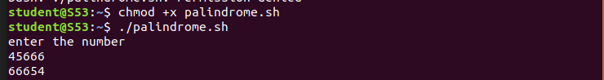

Amal Jyothi College of Engineering, Kanjirappally

